10.4.1 The DreamHome Case Study – An Overview
The first branch office of DreamHome was opened in 1992 in a city called Glasgow in the UK. Since then, the Company has grown steadily and now has several offices in most of the main cities of the UK. However, the Company is now so large that more and more administrative staff are being employed to cope with the ever-increasing amount of paperwork. Furthermore, the communication and sharing of information between offices, even in the same city, is poor. The Director of the Company, Sally Mellweadows feels that too many mistakes are being made and that the success of the Company will be short-lived if she does not do something to remedy the situation. She knows that a database could help in part to solve the problem and requests that a database application be developed to support the running of DreamHome. The Director has provided the following brief description of how DreamHome currently operates.
DreamHome specializes in property management, by taking an intermediate role between owners who wish to rent out their furnished property and clients of DreamHome who require to rent furnished property for a fixed period. DreamHome currently has about 2000 staff working in 100 branches. When a member of staff joins the Company, the DreamHome staff registration form is used. The staff registration form for Susan Brand is shown in Figure 10.1.

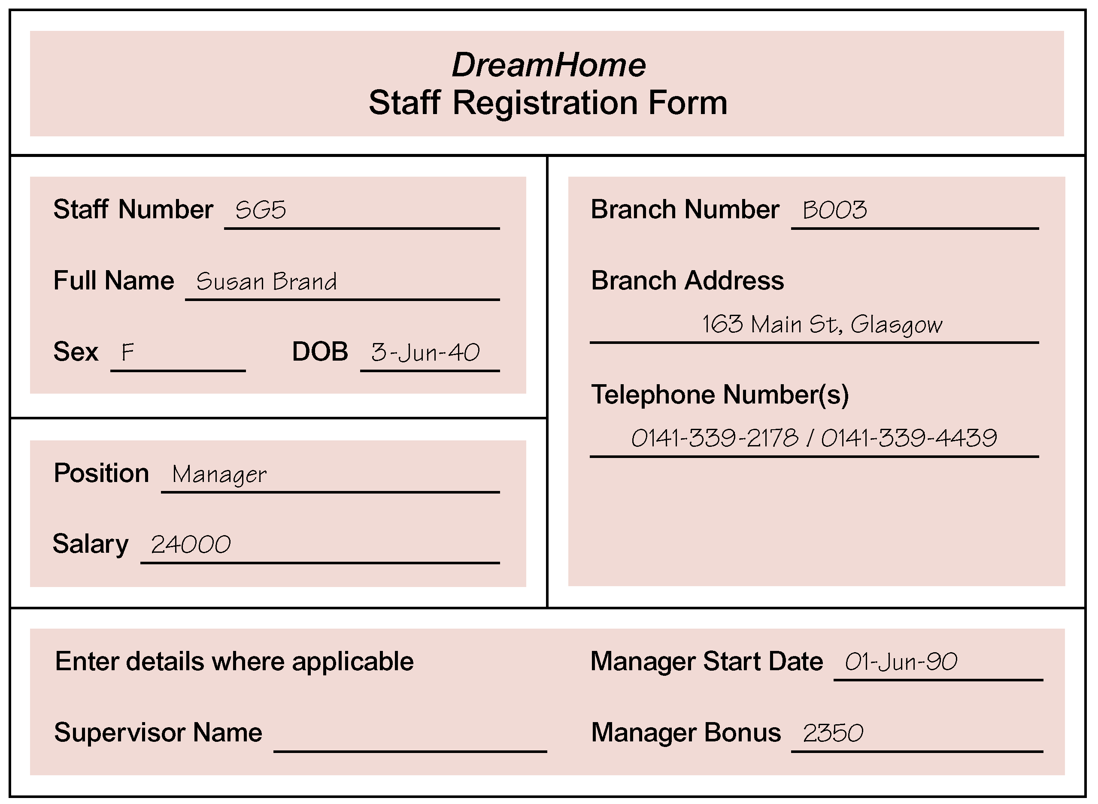
Figure 10.1 The DreamHome staff registration form for Susan Brand.
Each branch has an appropriate number and type of staff including a Manager, Supervisors, and Assistants. The Manager is responsible for the day-to-day running of a branch and each Supervisor is responsible for supervising a group of staff called Assistants. An example of the first page of a report listing the details of staff working at a branch office in Glasgow is shown in Figure 10.2.

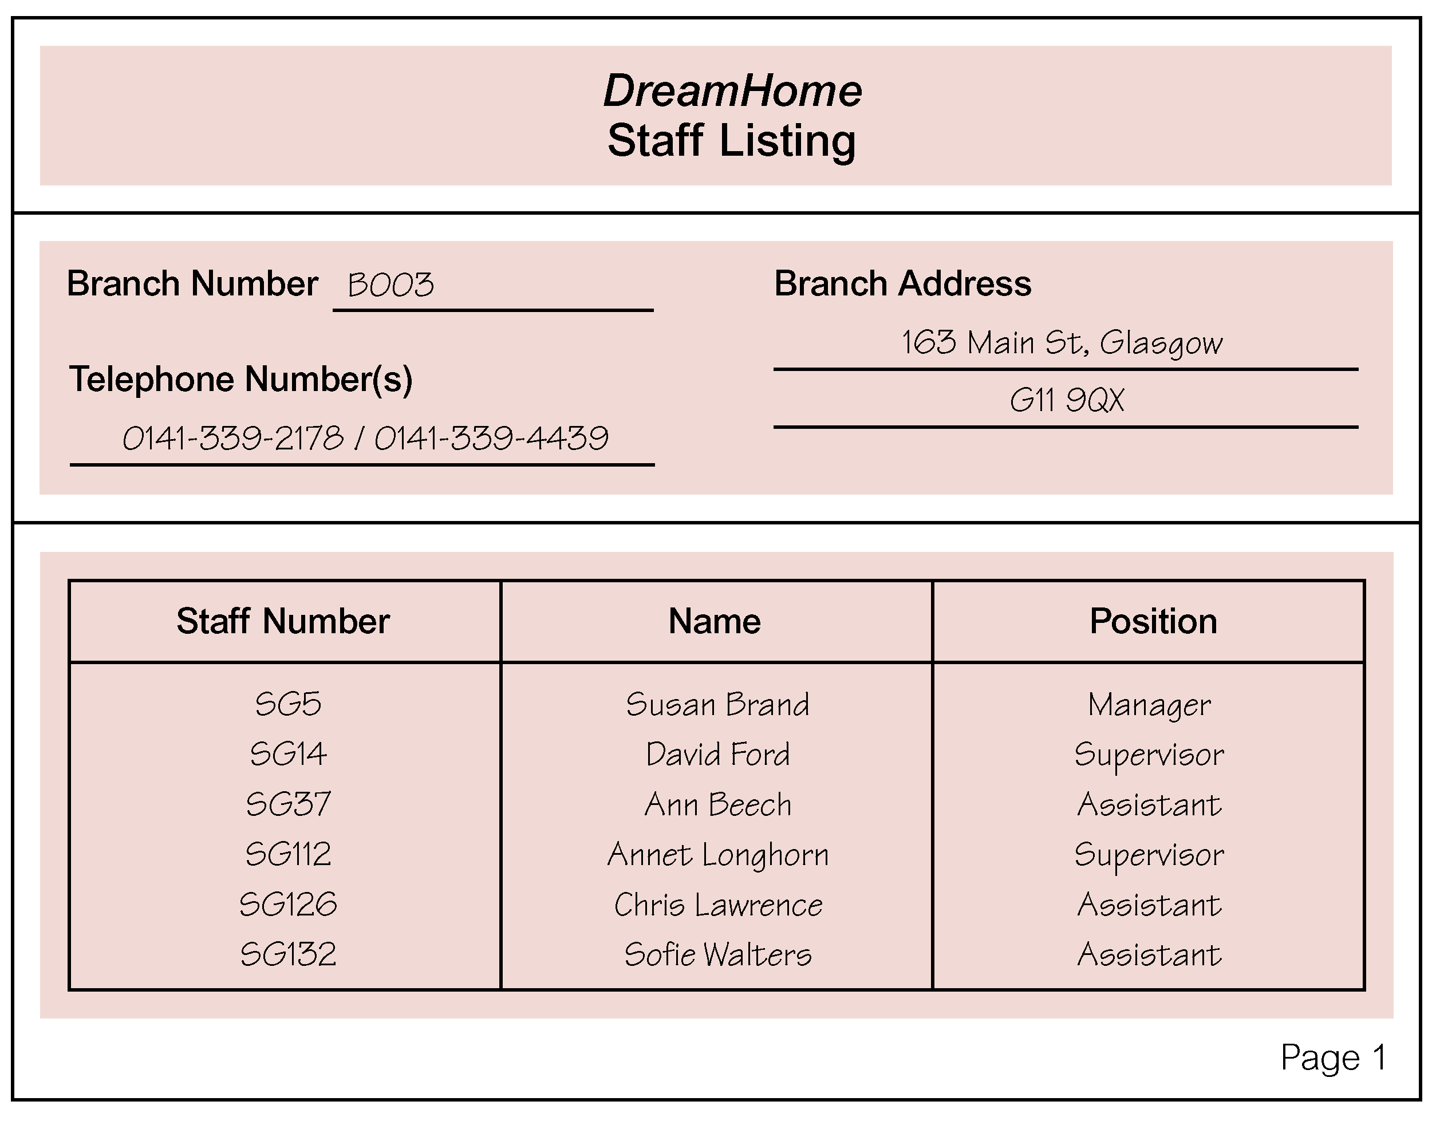
Figure 10.2 Example of the first page of a report listing the details of staff working at a DreamHome branch office in Glasgow.

Each branch office offers a range of properties for rent. To offer property through DreamHome, a property owner normally contacts the DreamHome branch office nearest to the property for rent. The owner provides the details of the property and agrees an appropriate rent for the property with the branch Manager. The registration form for a property in Glasgow is shown in Figure 10.3.

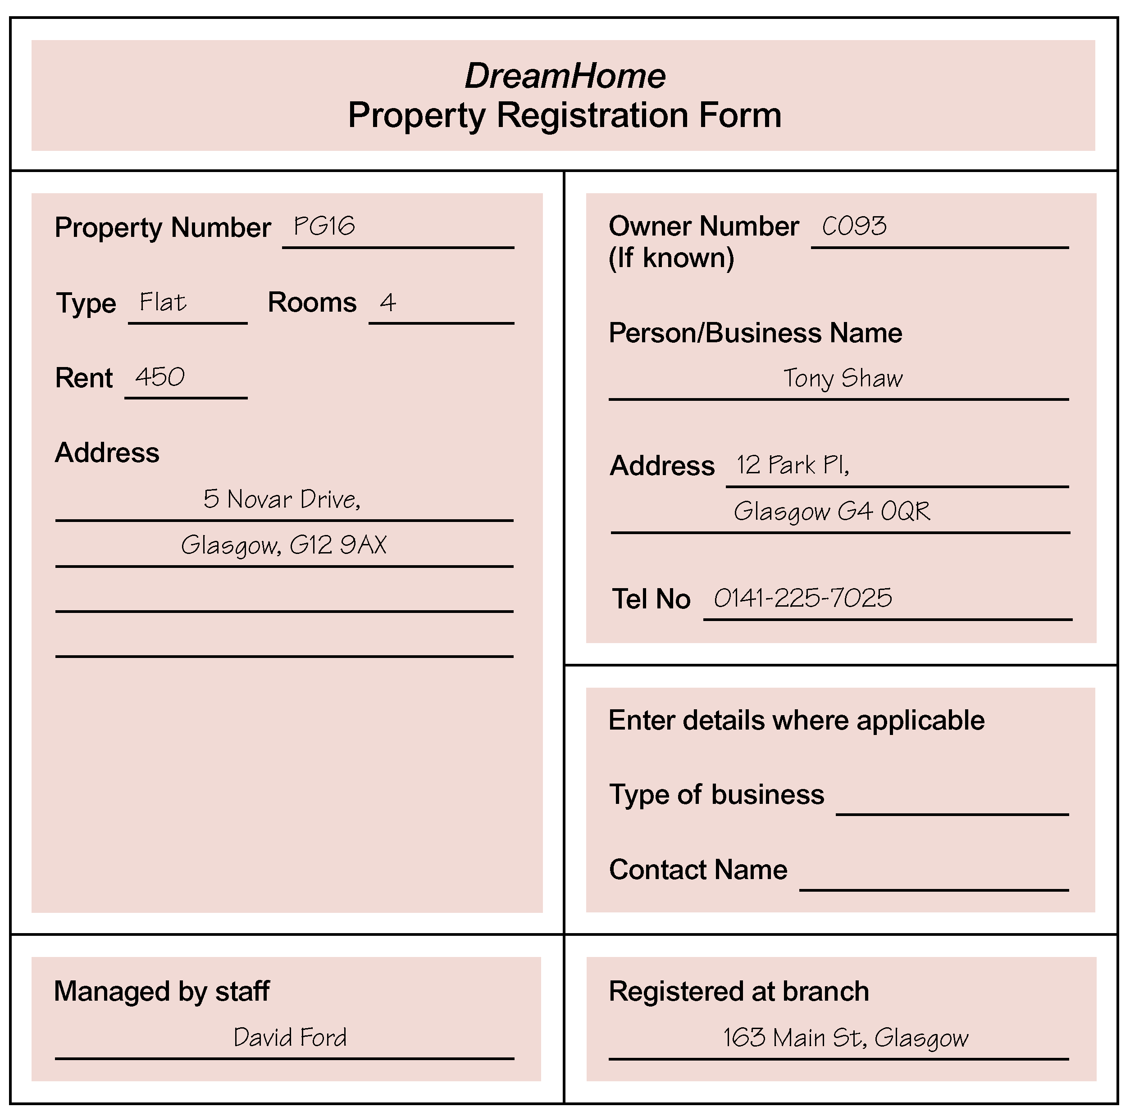

Figure 10.3 The DreamHome property registration form for a property in Glasgow.

Once a property is registered, DreamHome provides services to ensure that the property is rented out for maximum return for both the property owner and of course, DreamHome. These services include interviewing prospective renters (called clients), organizing viewings of the property by clients, advertising the property in the local or national newspapers (when necessary), and negotiating the lease. Once rented, DreamHome assumes responsibility for the property including the collection of rent.
Members of the public interested in renting out property must first contact their nearest DreamHome branch office to register as clients of DreamHome. However, before registration is accepted, a prospective client is normally interviewed to record personal details and preferences of the client in terms of property requirements. The registration form for a client called Mike Ritchie is shown in Figure 10.4.

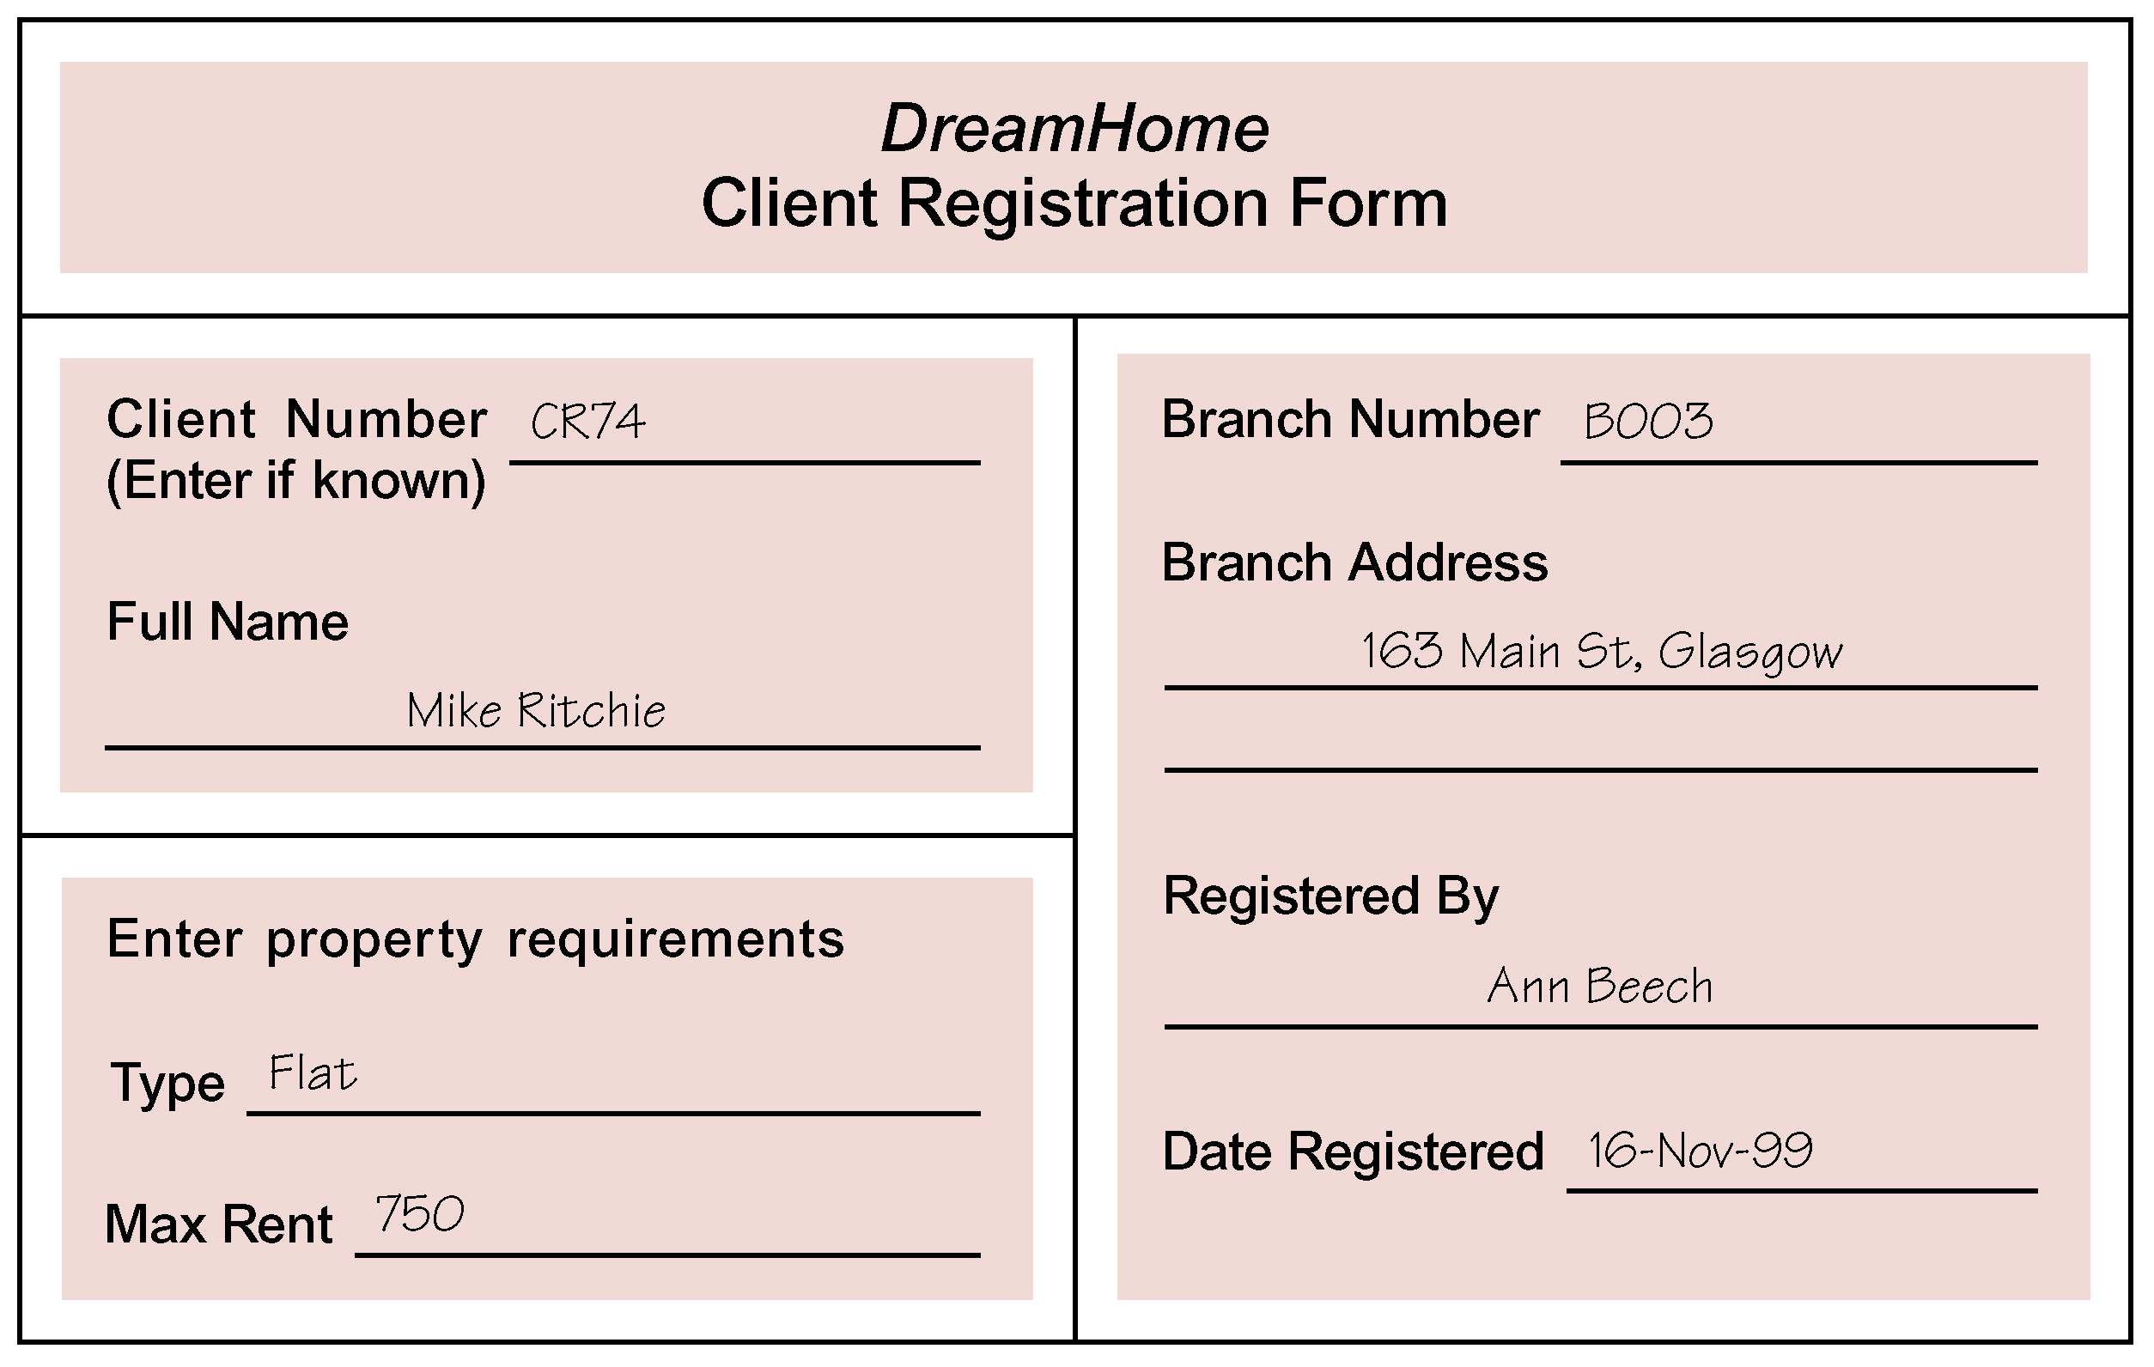

Figure 10.4 The DreamHome client registration form for Mike Ritchie.

Once registration is complete, clients are provided with weekly reports that list properties currently available for rent. An example of the first page of a report listing the properties available for rent at a branch office in Glasgow is shown in Figure 10.5.

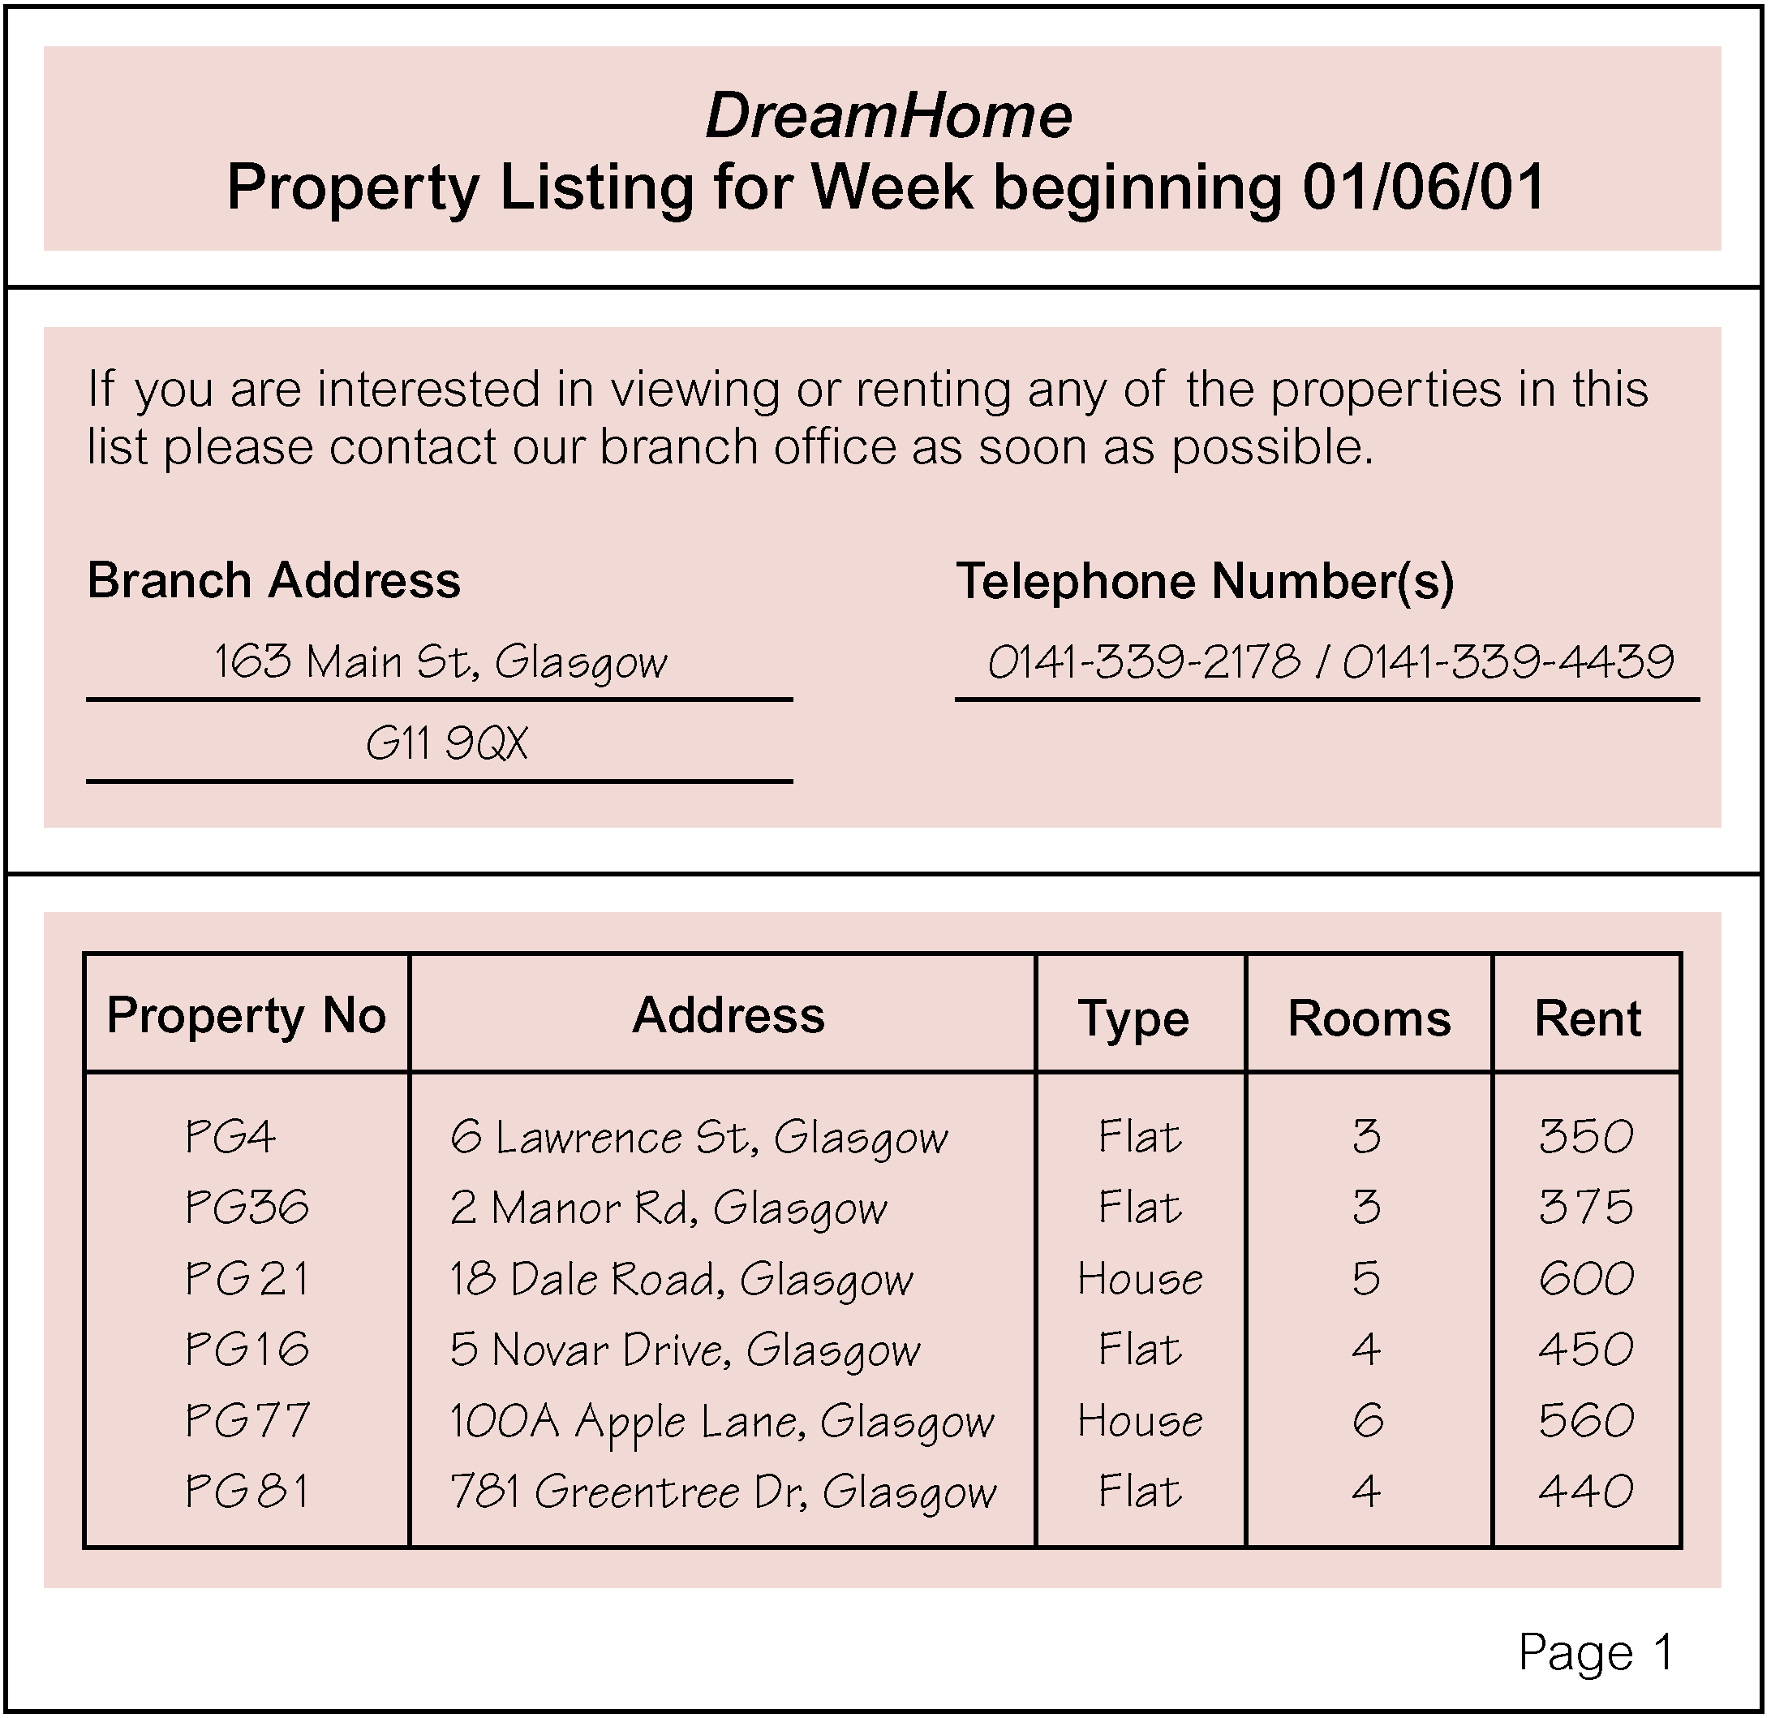
Figure 10.5 The first page of the DreamHome property for rent report listing property available at a branch in Glasgow.

Clients may request to view one or more properties from the list and after viewing will normally provide a comment on the suitability of the property. The first page of a report describing the comments made by clients on a property in Glasgow is shown in Figure 10.6. Properties that prove difficult to rent out are normally advertised in local and national newspapers.

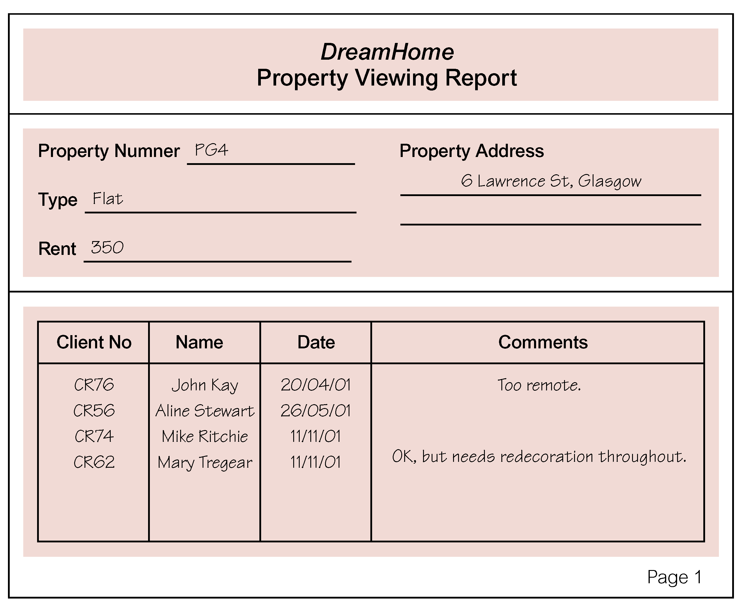
Figure 10.6 The first page of the DreamHome property viewing report for a property in Glasgow.

Once a client has identified a suitable property, a member of staff draws up a lease. The lease between a client called Mike Ritchie and a property in Glasgow is shown in Figure 10.7.

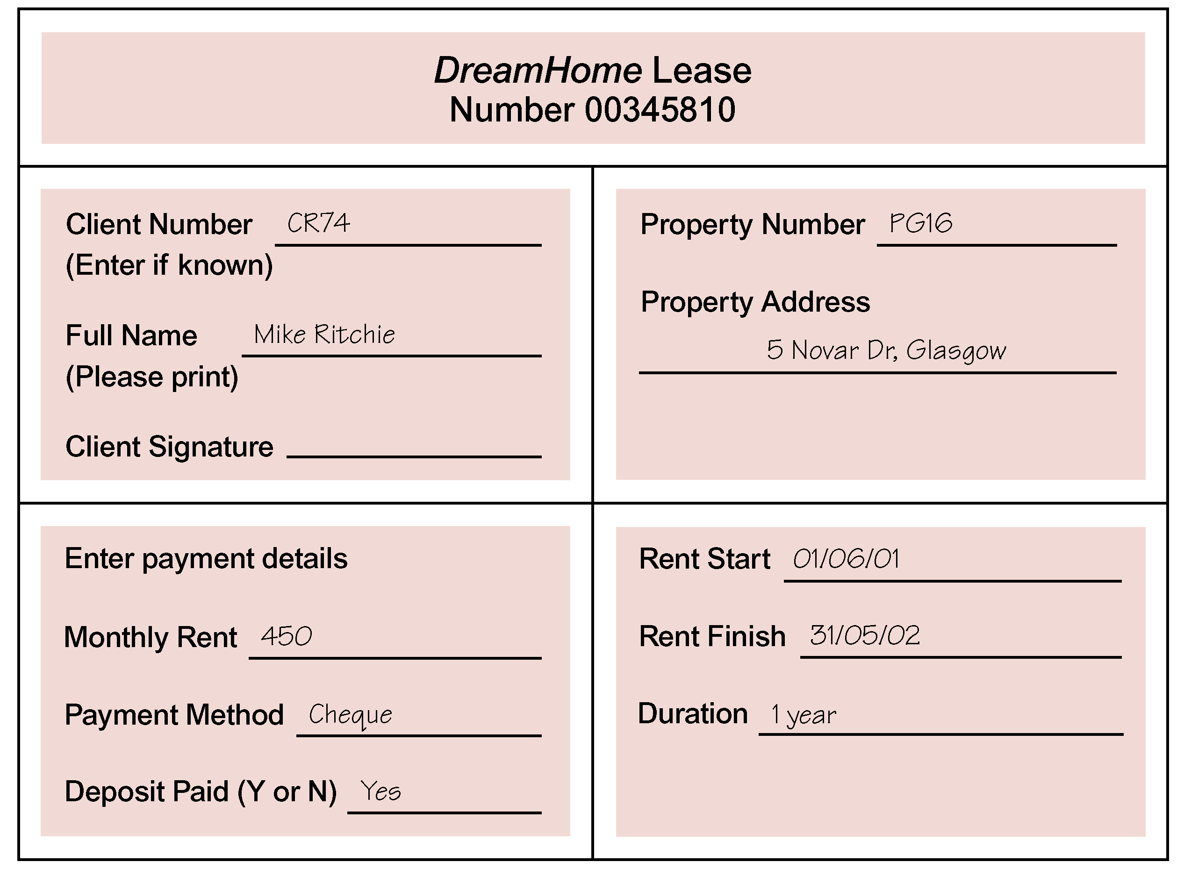

Figure 10.7 The DreamHome lease form for a client called Mike Ritchie renting a property in Glasgow.

At the end of a rental period a client may request that the rental be continued, however this requires that a new lease be drawn up. Alternatively, a client may request to view alternative properties for the purposes of renting.
10.4.2 The DreamHome Case Study – Database Planning
The first step in developing a database application is to clearly define the mission statement for the database project, which defines the major aims of the database application. Once the mission statement is defined, the next activity involves identifying the mission objectives, which should identify the particular tasks that the database must support (see Section 9.3).

Creating the mission statement for the DreamHome database application
We begin the process of creating a mission statement for the DreamHome database application by conducting interviews with the Director and any other appropriate staff, as indicated by the Director. Open-ended questions are normally the most useful at this stage of the process. Examples of typical questions we might ask include:

“What is the purpose of your Company?”
“Why do you feel that you need a database?”
“How do you know that a database will solve your problem?”

For example, the database developer may start the interview by asking the Director of DreamHome the following questions:

Database Developer “What is the purpose of your Company?”
Director “We offer a wide range of high quality properties for rent to clients registered at our branches throughout the UK. Our ability to offer quality properties, of course, depends upon the services we provide to property owners. We provide a highly professional service to property owners to ensure that properties are rented out for maximum return”.

Database Developer “Why do you feel that you need a database?”
Director “ To be honest we can’t cope with our own success. Over the past few years, we’ve opened several branches in most of the main cities of the UK, and at each branch we now offer a larger selection of properties to a growing number of clients. However, this success has been accompanied with increasing data management problems, which means that the level of service we provide is falling. Also, there’s a lack of cooperation and sharing of information between branches, which is a very worrying development.”

Database Developer “How do you know that a database will solve your problem?”
Director “All I know is that we are drowning in paperwork. We need something that will speed up the way we work by automating a lot of the day-to-day tasks that seem to take forever these days. Also, I want the branches to start working together. Databases will help to achieve this, won’t they?”

Responses to these types of questions should help to formulate the mission statement. An example mission statement for the DreamHome database application is shown in Figure 10.8. When we have a clear and unambiguous mission statement that the staff of DreamHome agree with, we move on to define the mission objectives.

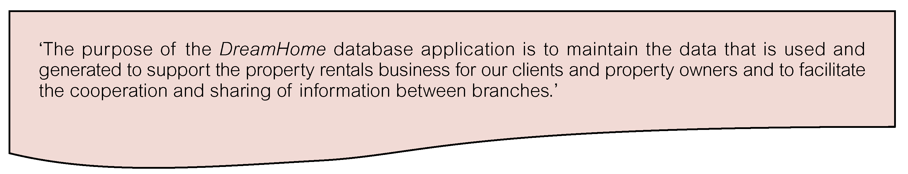
Figure 10.8 Mission statement for the DreamHome database application.
Creating the mission objectives for the DreamHome database application
The process of creating mission objectives involves conducting interviews with appropriate members of staff. Again, open-ended questions are normally the most useful at this stage of the process. To obtain the complete range of mission objectives, we interview various members of staff with different roles in DreamHome. Examples of typical questions we might ask include:

“What is your job description?”
“What kinds of tasks do you perform in a typical day?”
“What kinds of data do you work with?”
“What types of reports do you use?”
“What types of things do you need to keep track of?”
“What service does your company provide to your customers?”

These questions (or similar) are put to the Director of DreamHome and members of staff in the role of Manager, Supervisor, and Assistant. It may be necessary to adapt the questions as required depending on whom is being interviewed.

Director
Database developer “What role do you play for the company?”
Director “I oversee the running of the company to ensure that we continue to provide the best possible property rental service to our clients and property owners.”

Database developer “What kinds of tasks do you perform in a typical day?”
Director “I monitor the running of each branch by our Managers. I try to ensure that the branches work well together and share important information about properties and clients. I normally try to keep a high profile with my branch Managers by calling into each branch at least once or twice a month.“

Database developer “What kinds of data do you work with?”
Director “I need to see everything, well at least a summary of the data used or generated by DreamHome. That includes data about staff at all branches, all properties and their owners, all clients, and all leases. I also like to keep an eye on the extent to which branches advertise our properties in newspapers.”

Database developer “What types of reports do you use?”
Director “I need to know what’s going on at all the branches and there’s lots of them. I spend a lot of my working day going over long reports on all aspects of DreamHome. I need reports that are easy to access and that let me get a good overview of what’s happening at a given branch and across all branches.”

Database developer “What types of things do you need to keep track of?”
Director “As I said before, I need to have an overview of everything, I need to see the whole picture.”

Database developer “What service does your company provide to your customers?”
Director “We try to provide the best property rental service in the UK.”

Manager
Database developer “What is your job description?”
Manager “My job title is Manager. I oversee the day-to-day running of my branch to provide the best property rental service to our clients and property owners.”

Database developer “What kinds of tasks do you perform in a typical day?”
Manager “I ensure that the branch has the appropriate number and type of staff on duty at all times. I monitor the registering of new properties and new clients and the renting activity of our currently active clients. It’s my responsibility to ensure that we have the right number and type of properties available to offer our clients. I sometimes get involved in negotiate leases for our top of the range properties although due to my workload I often have to delegate this task to my Supervisors.”

Database developer “What kinds of data do you work with?”
Manager “I mostly work with data on the properties offered at my branch and the owners, clients, and leases. I also need to know when properties are proving difficult to rent out so that I can arrange for them to be advertised in newspapers. I need to keep an eye on this aspect of the business because advertising can get costly. I also need access to data about staff working at my branch and staff at other local branches. This is because I sometimes need to contact other branches to arrange management meetings or to borrow staff from other branches on a temporary basis to cover staff shortages due to sickness or during holiday periods. This borrowing of staff between local branches is informal and thankfully doesn’t happen very often. Besides data on staff, it would be helpful to see other types of data at the other branches such as data on property, property owners, clients, and leases, you know, to compare notes. Actually, I think the Director hopes that this database project is going to help promote cooperation and sharing of information between branches. However, some of the Managers I know are not going to be too keen on this because they think we’re in competition with each other. Part of the problem is that a percentage of a Manager’s salary is made up of a bonus, which is related to the number of properties we rent out.”

Database developer “What types of reports do you use?”
Manager “I need various reports on staff, property, owners, clients, and leases. I need to know at a glance which properties we need to lease out and what clients are looking for.”

Database developer “What types of things do you need to keep track of?”
Manager “I need to keep track of staff salaries. I need to know how well the properties on our books are being rented out and when leases are coming up for renewal. I also need to keep eye on our expenditure on advertising.”

Database developer “What service does you company provide to your customers?”
Manager “Remember that we have two types of customers, that is clients wanting to rent property and property owners. We need to make sure that our clients find the property they’re looking for quickly without too much legwork and at a reasonable rent and of course that our property owners see good returns from renting out their properties with minimal hassle.”

Supervisor
Database developer “What is your job description?”
Supervisor “My job title is Supervisor. I spend most of my time in the office dealing directly with our customers that is clients wanting to rent property and property owners. I’m also responsible for a small group of staff called Assistants and making sure that they are kept busy, but that’s not a problem as there’s always plenty to do, it’s never ending actually.”

Database developer “What kinds of tasks do you perform in a typical day?”
Supervisor “I normally start the day by allocating staff to particular duties, such as dealing with clients or property owners, organizing for clients to view properties, and the filing of paperwork. When a client finds a suitable property, I process the drawing up of a lease although the Manager must see the documentation before any signatures are requested. I keep client details up-to-date and register new clients when they want to join the Company. When a new property is registered, the Manager allocates responsibility for managing that property to me or one of the other Supervisors or Assistants”

Database developer “What kinds of data do you work with?”
Supervisor “I work with data about staff at my branch, property, property owners, clients, property viewings, and leases.”

Database developer “What types of reports do you use?”
Supervisor “Reports on staff and properties for rent.”

Database developer “What types of things do you need to keep track of?”
Supervisor “I need to know what properties are available for rent and when currently active leases are due to expire. I also need to know what clients are looking for. I need to keep our Manager up-to-date with any properties that are proving difficult to rent out.”

Assistant
Database developer “What is your job description?”
Assistant “My job title is Assistant. I deal directly with our clients.”

Database developer “What kinds of tasks do you perform in a typical day?”
Assistant “I answer general queries from clients about properties for rent. You know what I mean: “Do you have such and such type of property in a particular area of Glasgow?” I also register new clients and arrange for clients to view properties. When we’re not too busy I file paperwork but I hate this part of the job, it’s so boring.”

Database developer “What kinds of data do you work with?”
Assistant “I work with data on property and property viewings by clients and sometimes leases.”

Database developer “What types of reports do you use?”
Assistant “Lists of properties available for rent. These lists are updated every week.”

Database developer “What types of things do you need to keep track of?”
Assistant “Whether certain properties are available for renting out and what clients are still actively looking for property.”

Database developer “What service does your company provide to your customers?”
Assistant “We try to answer questions about properties available for rent such as: ‘Do you have a 2-bedroom flat in Hyndland, Glasgow?’ and ‘What should I expect to pay for a 1-bedroom flat in the city center?”

Responses to these types of questions should help to formulate the mission objectives. An example of the mission objectives for the DreamHome database are shown in Figure 10.9.

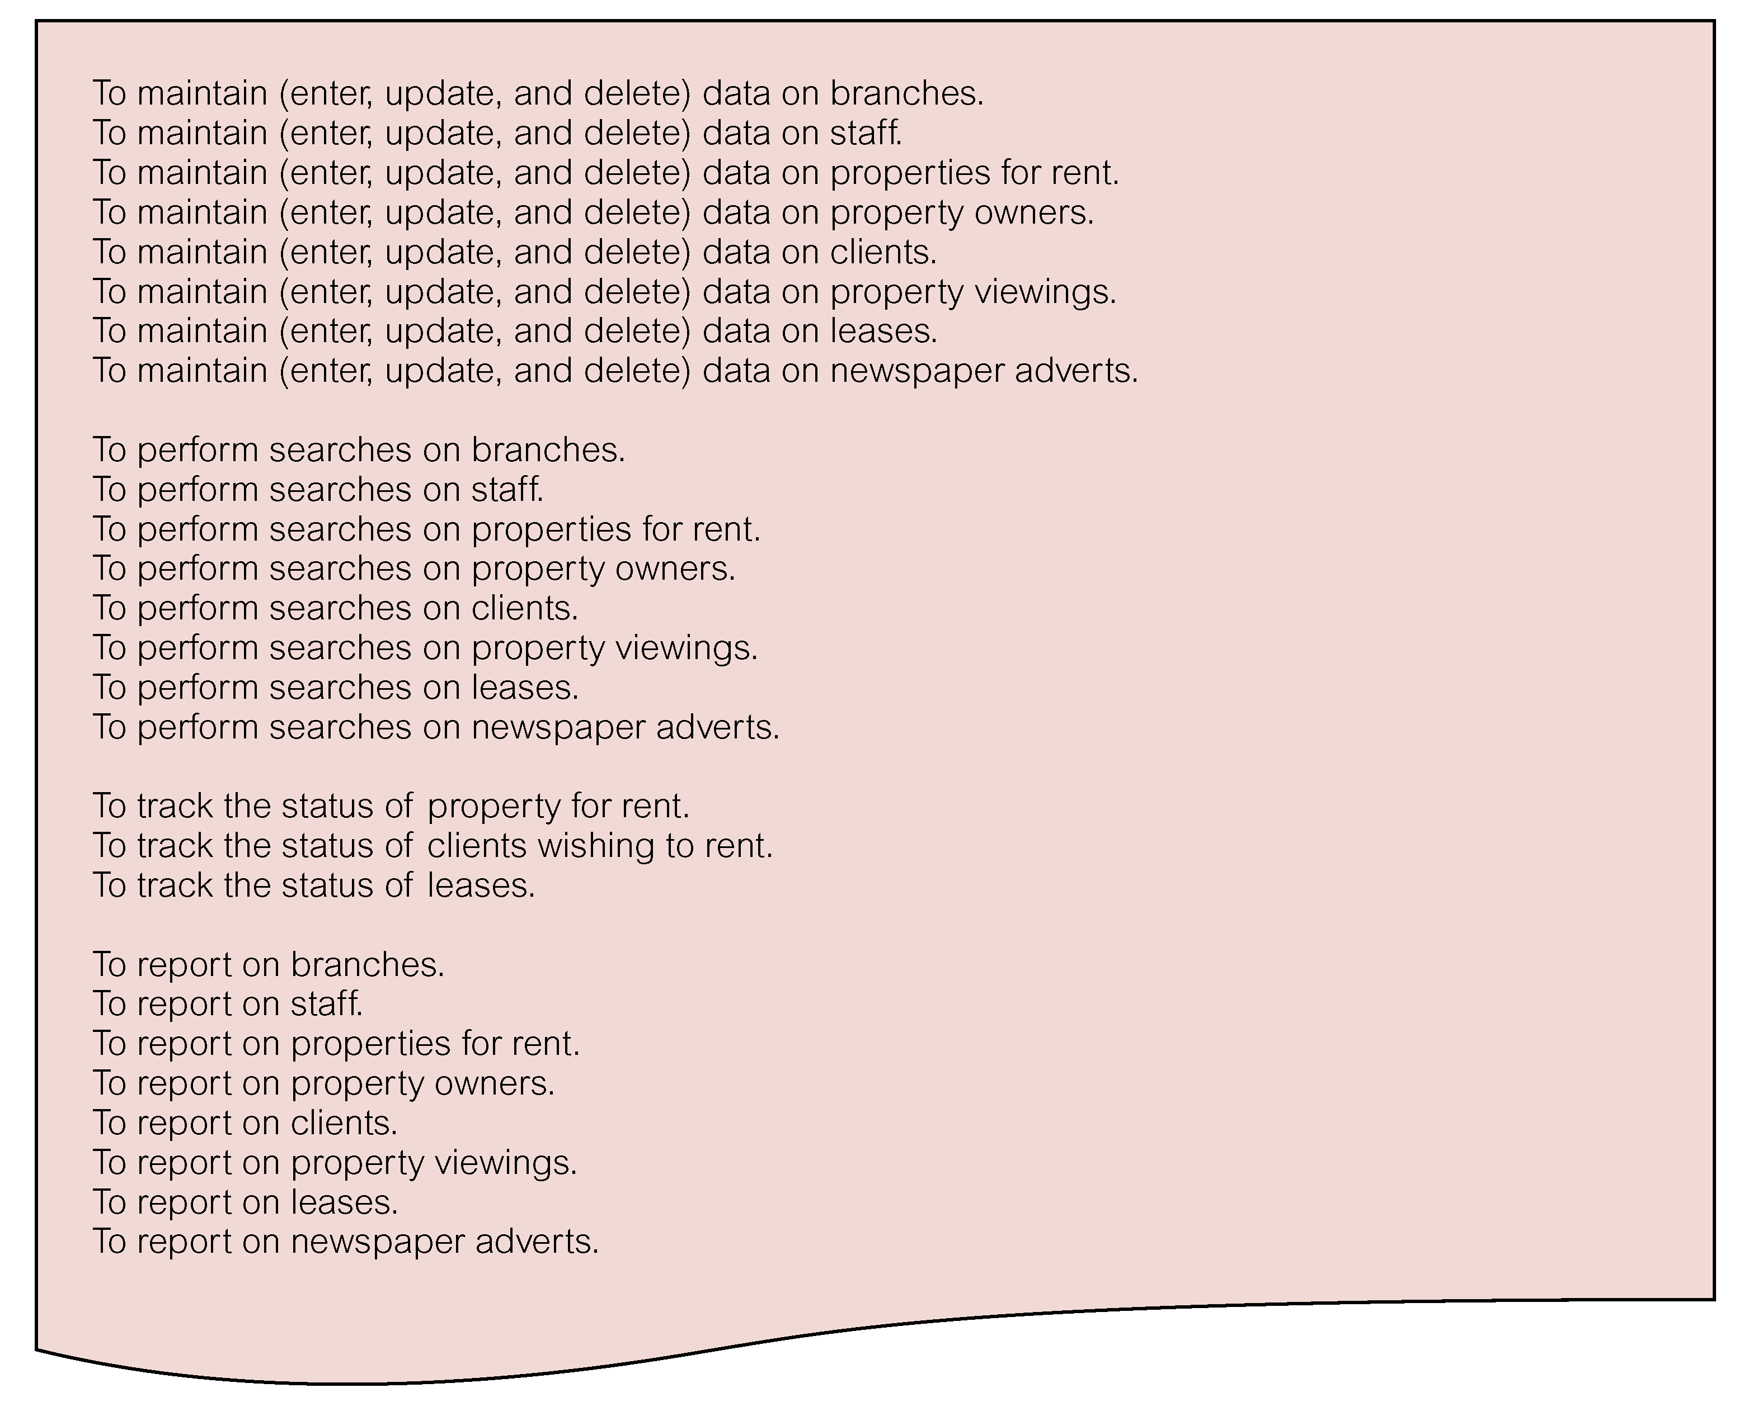
Figure 10.9 Mission objectives for the DreamHome database application.
10.4.3 The DreamHome Case Study – System Definition
The purpose of the system definition stage is to define the scope and boundary of the database application and its major user views. In Section 9.4.1, we described that a user view represents the requirements that should be supported by a database application as defined by a particular job role (such as Director or Supervisor) or business application area (such as property rentals or property sales).

Defining the systems boundary for the DreamHome database application
During this stage of the database application lifecycle, further interviews with users can be used to clarify or expand on data captured in the previous stage. However, additional fact-finding techniques can also be used including examining the sample documentation shown in the Section 10.4.1. The data collected so far is analyzed to define the boundary of the database application. The systems boundary for the DreamHome database application is shown in Figure 10.10.

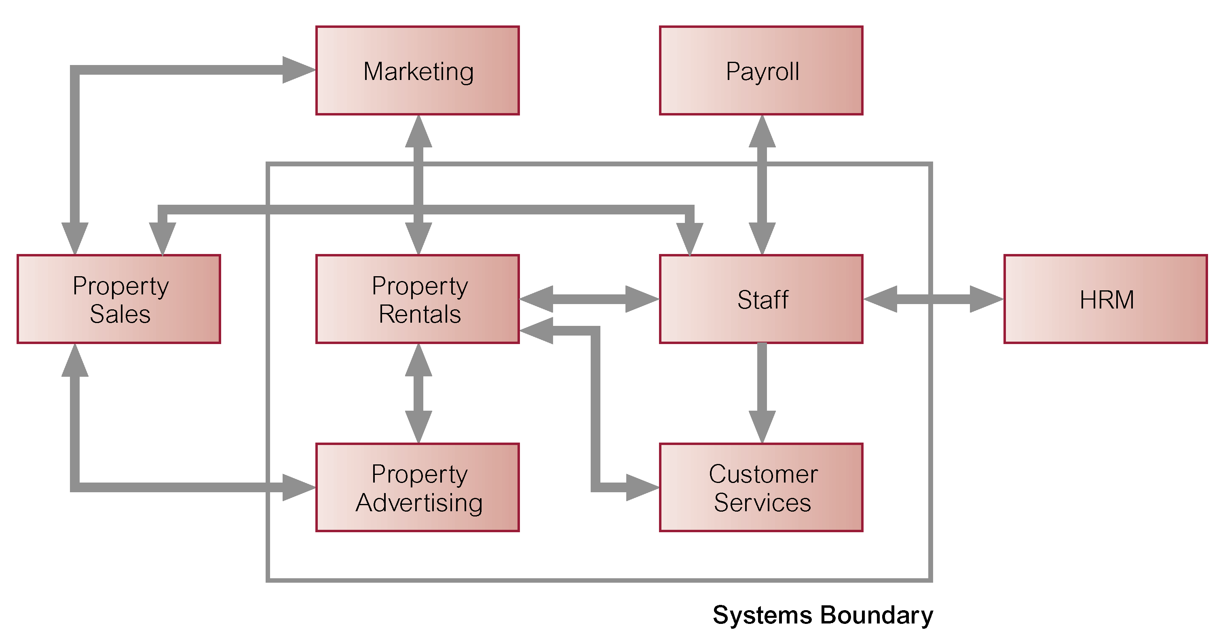

Figure 10.10 Systems boundary for the DreamHome database application.
Identifying the major user views for the DreamHome database application
We now analyze the data collected so far to define the main user views of the database application. The majority of data about the user views was collected during interviews with the Director and members of staff in the role of Manager, Supervisor, and Assistant. The main user views for the DreamHome database application are shown in Figure 10.11.
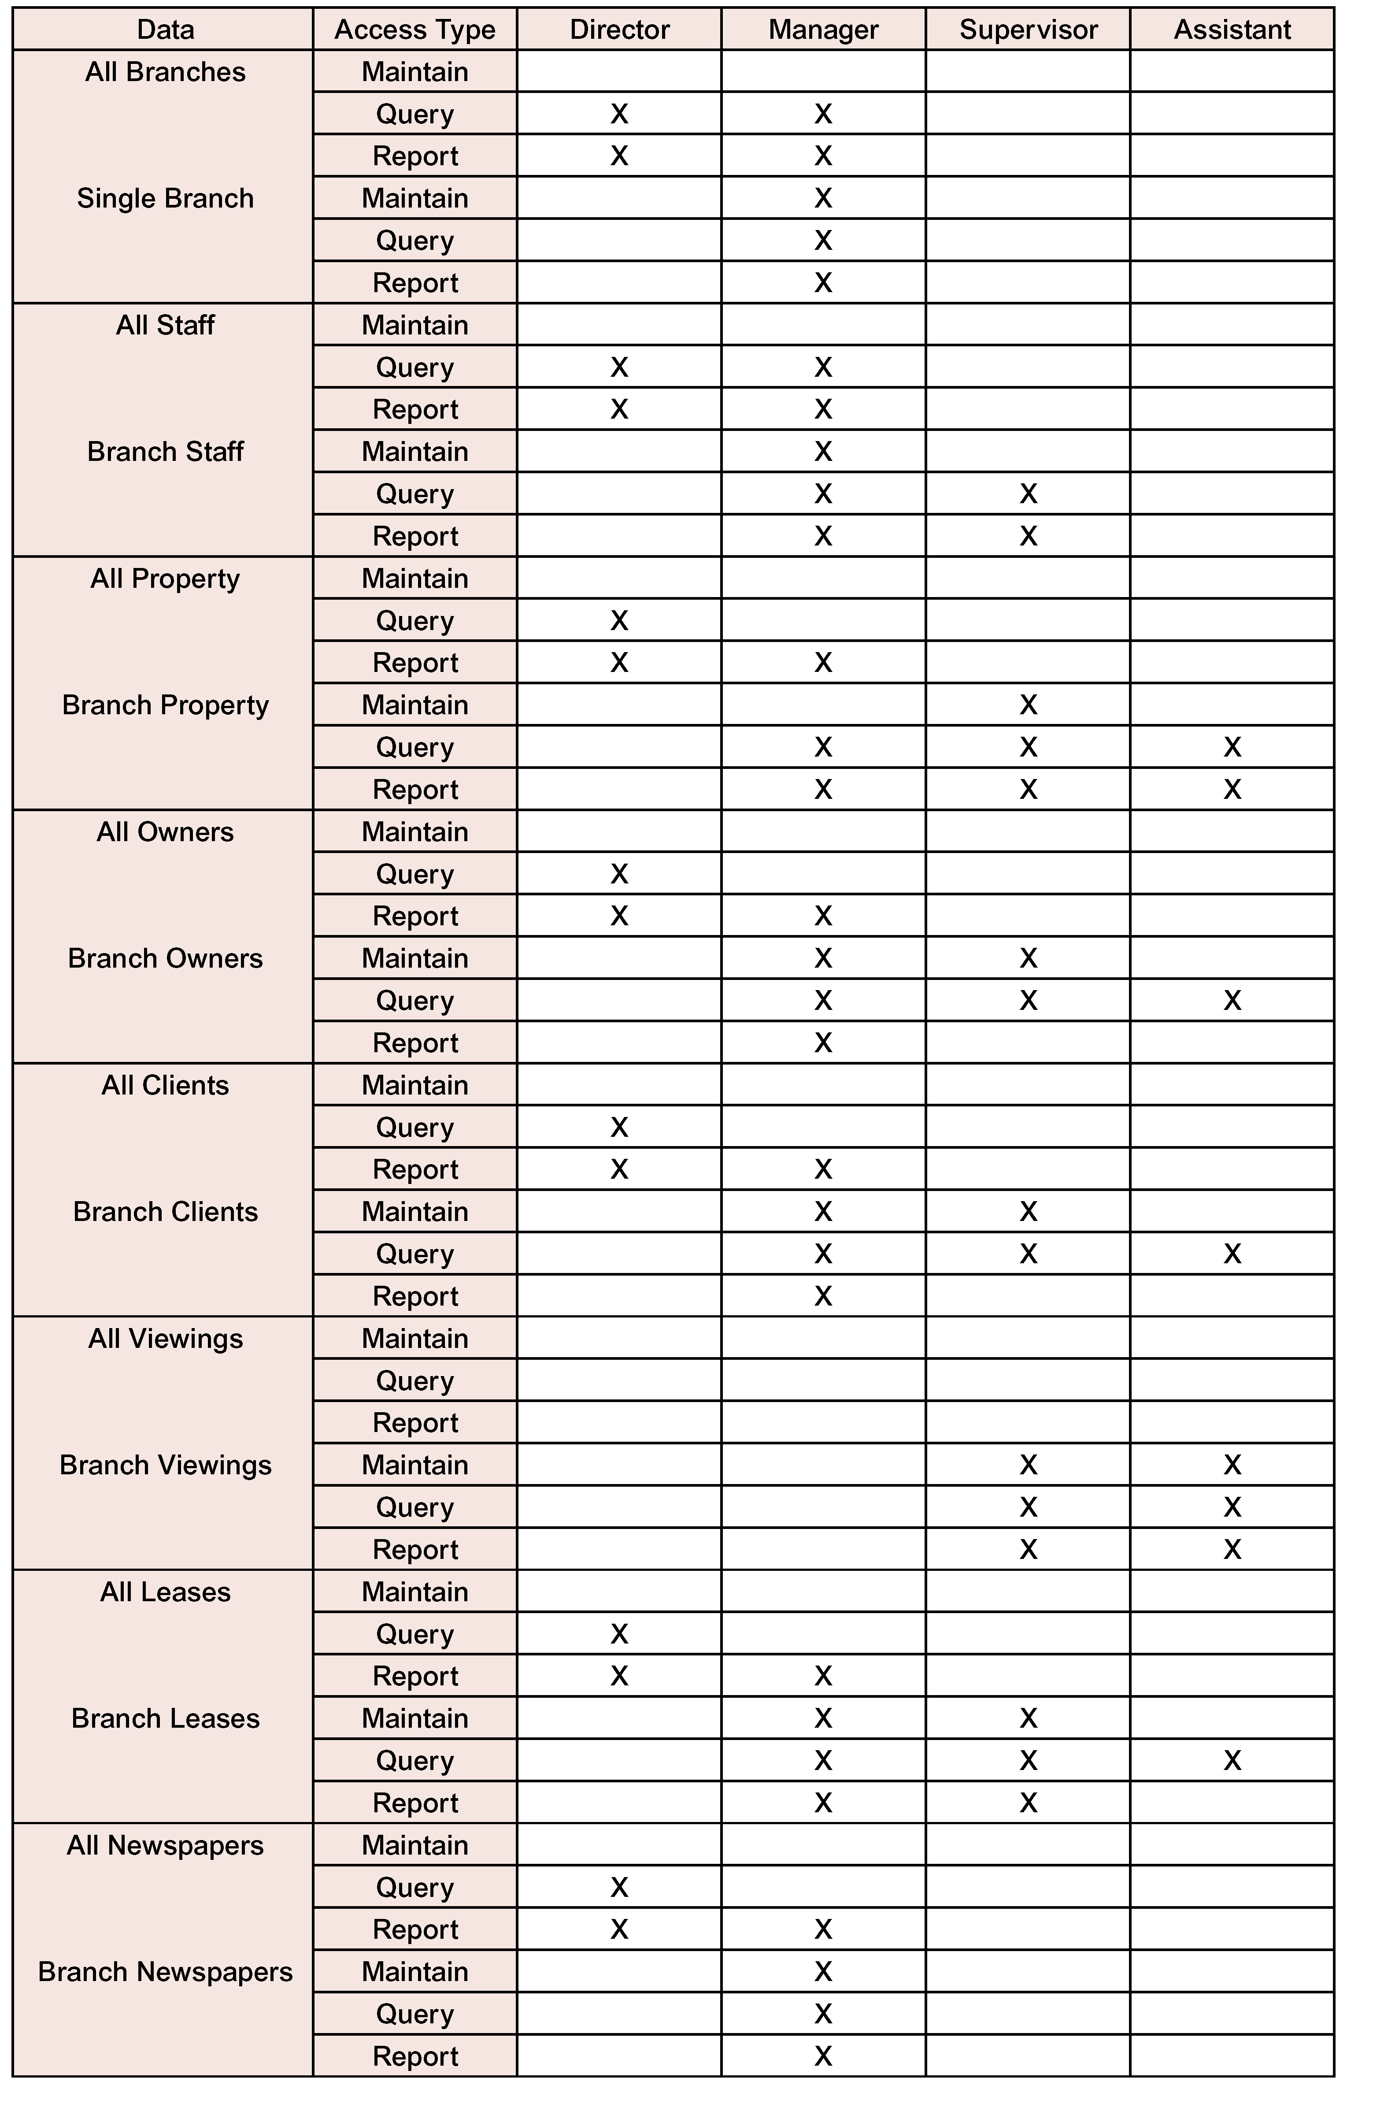
Figure 10.11 Major user views for the DreamHome database application.
10.4.4 The DreamHome Case Study – Requirements Collection and Analysis
During this stage, we continue to gather more details on the user views identified in the previous stage, to create a users’ requirements specification that describes in detail the data to be held in the database and how the data is to be used. While gathering more information on the user views, we also collect any general requirements for the system. The purpose of gathering this information is to create a systems specification, which describes any features to be included in the new database application such as networking and shared access requirements, performance requirements, and the levels of security required.
As we collect and analyze the requirements for the new system we also learn about the most useful and most troublesome features of the current system. When building a new database application it is sensible to try to retain the good things about the old system while introducing the benefits that will be part of using the new system.
An important activity associated with this stage is deciding how to deal with the situation where there is more than one user view. As we discussed in Section 9.6, there are three major approaches to dealing with multiple user views, namely the centralized approach, the view integration approach, and a combination of both approaches. We discuss how these approaches can be used shortly.
Gathering more information on the user views of the DreamHome database application
To find out more about the requirements for each user view, we may again use a selection of fact-finding techniques including interviews and observing the business in operation. Examples of the types of questions that we may ask about the data (represented as X) required by a user view includes:

“What type of data do you need to hold on X?”
“What sorts of things do you do with the data on X?”
For example, we may ask a Manager the following questions:
Database Developer “What type of data do you need to hold on staff?”
Manager “The types of data held on a member of staff is his or her full name, position, sex, date of birth, and salary.”

Database Developer “What sorts of things do you do with the data on staff?”
Manager “I need to be able to enter the details of new members of staff and delete their details when they leave. I need to keep the details of staff up-to-date and print reports that list the full name, position, and salary of each member of staff at my branch. I need to be able to allocate staff to Supervisors. Sometimes when I need to communicate with other branches, I need to find out the names and telephone numbers of Managers at other branches.”

We need to ask similar questions about all the important data to be stored in the database. Responses to these questions will help identify the necessary details for the users’ requirements specification.
Gathering information on the system requirements of the DreamHome database application
While conducting interviews about user views, we should also collect more general information on the system requirements. Examples of the types of questions that we may ask about the system includes:
“What transactions run frequently on the database?”
“What transactions are critical to the operation of the organisation?”
“When do the critical transactions run?”
“When are the low, normal, and high workload periods for the critical transactions?”
“What type of security do you want for the database application?”
“Is there any highly sensitive data that should only be accessed by certain members of staff?”
“What historical data do you want to hold?”
“What are the networking and shared access requirements for the database system?”
“What type of protection from failures or data loss do we want for your database application?”
For example, we may ask a Manager the following questions:
Database Developer “What transactions run frequently on the database?”
Manager “We frequently get requests either by phone or by clients who call into our branch to search for a particular type of property in a particular area of the city and for a rent no higher than a particular amount. We also need update-to-date information on properties and clients so that reports can be run off that show properties currently available for rent and clients currently seeking property.”

Database Developer “What transactions are critical to the operation of the business?”
Manager “Again, critical transactions include being able to search for particular properties and to print out reports with up-to-date lists of properties available for rent. Our clients would go elsewhere if we couldn’t provide this basic service.”

Database Developer “When do the critical transactions run?”
Manager “Everyday.”

Database Developer “When are the low, normal, and high workload periods for the critical transactions?”
Manager “We’re open six days a week. In general, we tend to be quiet in the mornings and get busier as the day progresses. However, the busiest time slots each day for dealing with customers is between 12 and 2pm and 5 and 7pm.”

We may ask the Director the following questions:
Database Developer “What type of security do you want for the database application?”
Director “I don’t suppose a database holding information for a property rental company holds very sensitive data, but I wouldn’t want any of our competitors to see the data on properties, owners, clients, and leases. Staff should only see the data necessary to do his or her job in a form that suits what they’re doing. For example, although it’s necessary for Supervisors and Assistants to see client details, client records should only be displayed one-at-a-time and not as a report.”

Database Developer “Is there any highly sensitive data that should only be accessed by certain members of staff?”
Director “As I said before, staff should only see the data necessary to do their jobs. For example, although Supervisors need to see data on staff, salary details should not be included.”

Database Developer “What historical data do you want to hold?
Director “I want to keep the details of clients and owners for a couple of years after their last dealings with us, so that we can mail shot them to tell them about our latest offers, and generally try to attract them back. I also want to be able to keep lease information for a couple of years so that we can analyze it to find out which types of properties and areas of each city are the most popular, which age groups rent most frequently, and so on.”

Database Developer “What are the networking and shared access requirements for the database system?
Director “I want all the branches networked to our main branch office, here in Glasgow, so that staff can access the system from wherever and whenever they need to. At most branches, I would expect about two or three staff to be accessing the system at any one time, but remember we have about 100 branches. Most of the time the staff should be just accessing local branch data. However, I don’t really want there to be any restrictions about how often or when the system can be accessed, unless it’s got real financial implications.”

Database Developer “What type of protection from failures or data loss do you want for your database application?”
Director “The best of course. All our business is going to be conducted using the database, so if it goes down, we’re sunk. To be serious for a minute, I think we probably have to back up our data every evening when the branch closes. What do you think?”

We need to ask similar questions about all the important aspects of the system. Responses to these questions should help identify the necessary details for the system requirements specification.
Managing the user views of the DreamHome database application
How do we decide whether to use the centralized or view integration approach, or a combination of both to manage multiple user views? One way to help make a decision is to examine the overlap in the data used between the user views identified during the system definition stage. Table 10.7 cross-references the Director, Manager, Supervisor, and Assistant user views with the main types of data we have identified for the DreamHome database application (namely branch, staff, property for rent, owner, client, property viewing, lease, and newspaper).

Table 10.7 Cross-reference of user views with the main types of data used by the DreamHome database application.

 | Director | Manager | Supervisor | Assistant
branch | X | X
staff | X | X | X
property for rent | X | X | X | X
owner | X | X | X | X
client | X | X | X | X
property viewing |  |  | X | X
lease | X | X | X | X
newspaper | X | X

We see from Table 10.7 that there is overlap in the data used by all user views. However, the Director and Manager user views and the Supervisor and Assistant user views show more similarities in terms of data requirements. For example, only the Director and Manager user views require data on branches and newspapers whereas only the Supervisor and Assistant user views require data on property viewings. Based on this analysis, we use the centralized approach to first merge the requirements for the Director and Manager user views (given the collective name of Branch view) and the requirements for the Supervisor and Assistant user views (given the collective name of Staff view). We then develop data models representing the Branch and Staff views and then use the view integration approach to merge the two data models.
Of course, for a simple case study like DreamHome, we could easily use the centralized approach for all user views but we will stay with our decision to create two collective views so that we can describe and demonstrate how the view integration approach works in practice in Chapter 15.
It is difficult to give precise rules as to when it is appropriate to use the centralized or view integration approaches. The decision should be based on an assessment of the complexity of the database application and the degree of overlap between the various user views. However, whether we use the centralized or view integration approach or a mixture of both to build the underlying database, ultimately we need to re-establish the original user views (namely Director, Manager, Supervisor, and Assistant) for the working database application. We will describe and demonstrate the establishment of the user views for the database application in Chapter 16.
All of the information gather so far on each view of the database application is describe in a document called a users’ requirements specification. The users’ requirements specification describes the data requirements for each view and examples of how the data is used by the view. For easy of reference the users’ requirements specifications for the Branch and Staff views of the DreamHome database application are given in Appendix A. In the remainder of this chapter, we present the general systems requirements for the DreamHome database application.
The systems specification for the DreamHome database application
The systems specification should list all the important features for the DreamHome database application. The types of features that should be described in the systems specification include:
- Initial database size,
- Database rate of growth,
- The types and average number of record searches,
- Networking and shared access requirements,
- Performance,
- Security,
- Backup and recovery,
- Legal issues.
Systems Requirements for DreamHome Database Application
Initial database size
- There are approximately 2000 members of staff working at over 100 branches. There is an average of 20 and a maximum of 40 members of staff at each branch.
- There are approximately 100000 properties available at all branches. There is an average of 1000 and a maximum of 3000 properties at each branch.
- There are approximately 60000 property owners. There is an average of 600 and a maximum of 1000 property owners at each branch.
- There are approximately 100000 clients registered across all branches. There is an average of 1000 and a maximum of 1500 clients registered at each branch.
- There are approximately 4000000 viewings across all branches. There is an average of 40000 and a maximum of 100000 viewings at each branch.
- There are approximately 400000 leases across all branches. There are an average of 4000 and a maximum of 10000 leases at each branch.
- There are approximately 50000 newspaper adverts in 100 newspapers across all branches.

Database rate of growth
- Approximately 500 new properties and 200 new property owners are added to the database each month.
- Once a property is no longer available for renting out, the corresponding record is deleted from the database. Approximately 100 records of properties are deleted each month.
- If a property owner does not provide properties for rent at anytime within a period of two years, his or her record is deleted. Approximately 100 property owner records are deleted each month.
- Approximately 20 members of staff join and leave the company each month. The records of staff who have left the company are deleted after one year. Approximately 20 staff records are deleted each month.
- Approximately 1000 new clients register at branches each month. If a client does not view or rent out a property at anytime within a period of two years, his or her record is deleted. Approximately 100 client records are deleted each month.
- Approximately 5000 new viewings are recorded across all branches each day. The details of property viewings are deleted one year after the creation of the record.
- Approximately 1000 new leases are recorded across all branches each month. The details of property leases are deleted two years after the creation of the record.
- Approximately 1000 newspaper adverts are placed each week. The details of newspaper adverts are deleted one year after the creation of the record.

The types and average number of record searches
- Searching for the details of a branch – approximately 10 per day.
- Searching for the details of a member of staff at a branch - approximately 20 per day.
- Searching for the details of a given property - approximately 5000 per day (Monday to Thursday), approximately 10000 per day (Friday and Saturday). Peak workload 17.00-19.00 daily.
- Searching for the details of a property owner - approximately 100 per day.
- Searching for the details of a client - approximately 1000 per day (Monday to Thursday), approximately 2000 per day (Friday and Saturday). Peak workload 17.00-19.00 daily.
- Searching for the details of a property viewing - approximately 2000 per day (Monday to Thursday), approximately 5000 per day (Friday and Saturday). Peak workload 17.00-19.00 daily.
- Searching for the details of a lease - approximately 1000 per day (Monday to Thursday), approximately 2000 per day (Friday and Saturday). Peak workload 17.00-19.00 daily.

Networking and shared access requirements
All branches should be securely networked to a centralized database located at DreamHome’s main office in Glasgow.
The system should allow for at least two to three people concurrently accessing the system from each branch. Consideration needs to be given to the licensing requirements for this number of concurrent accesses.

Performance
- During opening hours but not during peak periods expect less then 1 second response for all single record searches. During peak periods (17.00-19.00 daily) expect less then 5 second response for each search.
- During opening hours but not during peak periods expect less then 5 second response for each multiple record search. During peak periods (17.00-19.00 daily) expect less then 10 second response for each multiple record search.
- During opening hours but not during peak periods expect less then 1 second response for each update/saves. During peak periods (17.00-19.00 daily) expect less then 5 second response for each updates/saves.

Security
- The database should be password protected.
- Each member of staff should be assigned database access privileges appropriate to a particular user view, namely Director, Manager, Supervisor, or Assistant.
- Staff should only see the data necessary to do his or her job in a form that suits what they are doing.

Backup and Recovery
The database should be backed up daily at 12 midnight.

Legal Issues
Each country has laws that govern the way that the computerized storage of personal data is handled. As the DreamHome database holds data on staff, clients, and property owners any legal issues that must be complied with should be investigated and implemented.

